CAPSTONE I

Intro

Michael Jordan is generally considered the undisputed greatest basketball player of all time. The question is, what made him such a winner? What stat(s) was he so far ahead on in his competition that he was able to win 6 championships? Shaquille O’Neal is considered one of the most dominant centers of all time and personally took home 4 championships as well. How was Michael able win several more if their statistical outputs were merely the same? This project will dive deep into these very questions.

Hypothesis

*The goal of this project is to perform a****descriptive statistical analysis****focused on the correlation between variables that most contributed to winning NBA titles for both Michael Jordan and Shaquille O’Neal.*

Stats Used

**PTS (Points)** – Amount of points player scores in a game

**REB (Rebounds)** – Amount of rebounds player has in a game

**AST (Assists)** – Amount of assists player has in a game

**STL (Steals)** – Amount of steals player has in a game

**BLK (Blocks)** – Amount of blocks player has in a game

**MP (Minutes Played)** – Total minutes player is in game

**PRASB (Points+Rebounds+Assists+Steals+Blocks)** – An aggregation of a player’s total points, rebounds, assists, steals, and blocks for the game

**PRASB_per_Min (PRASB per Minute)** – Total PRASB/minutes played in game

**GmSc (Game Score)** – A composite metric used to measure a player’s impact for a single game (40 is an outstanding performance, 10 is an average performance, etc.)

**Diff (Team Point Differential)** – The amount of points the team won or lost the game by

Initial Findings

This is a summary table of MJ and Shaq’s average career stats in all major box score categories grouped by games they won versus the ones they lost.

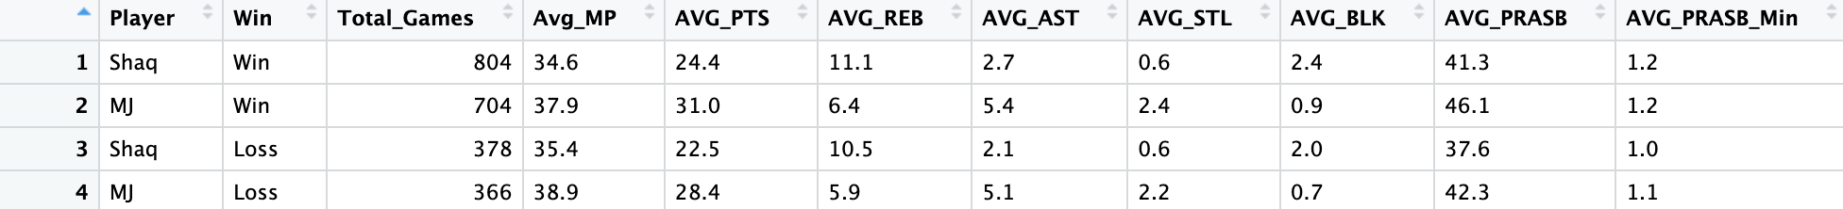**MJ and Shaq Win/Loss Splits Career Stats**

***Key Takeaways***

* MJ averaged a few more minutes per game for his whole career than Shaq, attributing to his slightly higher stat totals
* Shaq averaged significantly more blocks per game while MJ averaged far more steals
* Shaq would frequently get over 10+ rebounds per game but MJ was always around 30 points per game
* Both players were slightly worse statistically in their losses
  + Attributing to the value each added to their teams in terms of winning – the better they played, the more likely they were to win
* When using the PRASB statistic, (sum of a player’s points, rebounds, assists, steals, and blocks), these two legends averaged the same amount on a per minute basis on games that they won
* If Shaq played more minutes, there’s an argument that he’d have a higher AVG_PRASB for his entire career

Informational Plots

**MJ and Shaq PRASB Plot Over Career**

**MJ and Shaq Regression PRASB vs Age Plot**

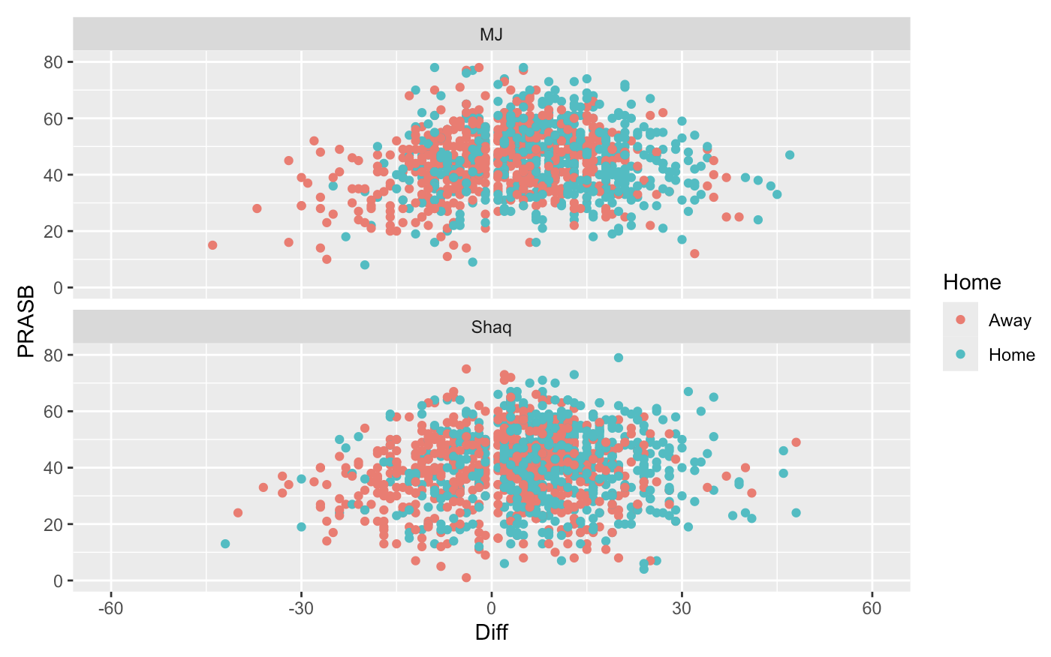**MJ and Shaq PRASB vs Team Point Differential**

*Key Takeaways*

* Over both their illustrious careers, these two had practically the same player performance arc regarding PRASB as well as winning their first three titles in a row around the same age of late 20s/early 30s
  + The only difference is Michael Jordan missed a few years to play baseball, but then came back to the same Chicago Bulls team, if not better, whereas Shaq won one more title in his mid 30s but tailored off afterwards because of his declining play and bouncing around multiple teams
* In the regression plot, there’s more of a relationship between Age and PRASB with Shaq’s career than MJ’s indicated by the higher R2 value for both wins and losses
  + In this context, MJ is even more of an outlier because his PRASB per game did necessarily dip as much as Shaq’s as he got older
    - The second halves of their careers differ in this sense that MJ was able to lead his team to three more titles in his mid-thirties
    - Shaq was the #2 option on his team for his one title in his mid-thirties as he was led mostly by then 24-year-old future Hall of Famer Dwyane Wade
* The third plot right above shows how well each player played in home vs away games with both players clearly winning more games at home as well as playing overall slightly better
  + Conversely, their performances would not necessarily dip in an away loss attributing to their consistency

Conclusion

As stated in the beginning, Michael Jordan and Shaq are two of the greatest players of all time. The only statistical difference between the two is the extended peak longevity MJ had in his mid-thirties that helped drive him and the Chicago Bulls to a second three-peat in the late 90s. They’re a couple theories as to how this happened. They’re two gaps in the PRASB vs Age plots above: the first is after MJ won his first three titles. He considered his career complete and wanted to try and play professional baseball. Long story short, I believe those two years off from running around playing professional basketball and instead playing (the more stationary) baseball helped reset his body, and when he triumphantly returned, he had this renewed passion to go out and win it all again. That’s just one theory. Another theory relates to the two player’s physical statures: Shaq is an extremely large human at 7 ft 2in and over 300 lbs. while Michael was a very trim, averaged sized shooting guard at 6 ft 6in. Those differences in body types could be a major factor as to why Shaq’s peak play didn’t necessarily prolong as long as Michael’s did. His body naturally couldn’t handle the wear and tear needed to play professional basketball for as long someone who’s smaller and doesn’t have to hold as much weight. Several other reasons may be along the lines of Shaq and his Hall of Fame teammate Kobe Bryant not getting along towards the end of their dynasty run, meaning Shaq left a formidable Lakers franchise to go elsewhere while Michael won all his titles on the same team.

They’re many reasons why Michael Jordan is considered the greatest and Shaq is more considered in the top 10-15 players of all time. A lot of these reasons are difficult to describe with statistical analysis because so much of winning as a professional athlete is more mental than physical. All professional athletes already have incredible skill level in their sport, that’s why they’re professional athletes. But what drives them to be a pro athlete? Is it money? Is it fame? Is it forced up them by their parents or coaches when they were young? **Or do they just want to win and do whatever it takes to win?** That’s the essence of Michael Jordan when people talk about his almost mythical lore. Yes, he is one of the most incredibly skilled and gifted athletes ever, but when the buzzer sounded, there wasn’t anyone else in the arena or watching on television who wanted to win that game more than Michael Jordan.